

Inputs and outputs

Introduction to inputs & outputs
This is where you’ll discover the micro:bit’s super power! Your students can learn to make the physical device work using its many inputs and outputs and combine real interaction while working in code.
The projects highlighted below make use of the micro:bit’s LED output to create images and animations and the speaker (sound output), to play sounds and music. Some of the device's inputs are explored as ways of activating such outputs.
The projects are split into different ability levels so you can find the projects to suit your students: Getting started, Next steps and Aiming further - for more confident users.

Using micro:bit to teach the concept
Using the micro:bit provides learners with a simple and engaging introduction to working with inputs and outputs in code and the physical world.
With only two commands required to construct a program that uses the micro:bit’s LEDs to display an image, students will be enthused by their creations and committed to furthering their understanding in order to create more.
This enthusiasm can be used to explore how to construct programs that use the LEDs to display animations and repeating patterns and further develop students’ conceptual understanding of sequencing and repetition (including the use of both infinite and count-controlled loops). Their understanding can be deepened by applying these concepts when programming the micro:bit to make sounds and music through the use of its speaker.
When students are confident in constructing programs that use the outputs of the LEDs and sounds, they can be introduced to some of the micro:bit’s inputs.
First students will explore how these can be used as a trigger an output and then as a way of controlling more than one output on the micro:bit. Students can even be challenged to combine their knowledge, skills and understanding to program an animation with a supporting soundtrack.

Developing students skills
In all the projects listed below, students will have the opportunity to develop their debugging skills.
The levels of engagement students have with the micro:bit, provides a platform for them to develop resilience when locating and replacing the bugs in their programs as they are provided with a tangible purpose to fix their code.
A real advantage of using a micro:bit to explore a range of input and output devices is that it can be done without the need of attaching additional hardware to the micro:bit, allowing for maximum learning time.

What students will learn
This set of micro:bit projects for teaching and learning inputs and outputs supports students’ understanding of the following concepts.

Concepts covered
Programming: Debugging, Sequence, Loops / repetition
Computational thinking: Algorithms, Abstraction, Decomposition, Pattern recognition
Computer systems: Control, Inputs and outputs.

UK curriculum links
Find out the primary curriculum links for this set of micro:bit projects.

National Curriculum in England

Computing
Curriculum aims
- can understand and apply the fundamental principles and concepts of computer science, including abstraction, logic, algorithms and data representation
- can analyse problems in computational terms, and have repeated practical experience of writing computer programs in order to solve such problems
- can evaluate and apply information technology, including new or unfamiliar technologies, analytically to solve problems
Students should be taught to:
- design, write and debug programs that accomplish specific goals, including controlling or simulating physical systems;
- use sequence… and repetition in programs; work with … various forms of input and output
- use logical reasoning to explain how some simple algorithms work and to detect and correct errors in algorithms and programs

Design and technology
Students should be taught to:
- apply their understanding of computing to program, monitor and control their products

Art and design
Students should be taught to:
- create sketch books to record their observations and use them to review and revisit ideas
- improve their mastery of art and design techniques, including drawing, painting and sculpting with a range of materials

Languages
Students should be taught to:
- explore the patterns and sounds of language through songs and rhymes and link the spelling, sound and meaning of words
- develop accurate pronunciation and intonation so that others understand when they are reading aloud or using familiar words and phrases

Geography
Students should be taught to:
- describe and understand key aspects of physical geography, including: volcanoes and earthquakes

Scotland Curriculum for Excellence

Technologies, computing science
- I can explore and comment on processes in the world around me making use of core computational thinking concepts and can organise information in a logical way (TCH 1-13a)
- I understand the instructions of a visual programming language and can predict the outcome of a program written using the language (TCH 1-14a)
- I can demonstrate a range of basic problem-solving skills by building simple programs to carry out a given task, using an appropriate language (TCH 1-15a)
- I understand the operation of a process and its outcome. I can structure related items of information. (TCH 2-13a)
- I can explain core programming language concepts in appropriate technical language (TCH 2-14a)
- I can create, develop and evaluate computing solutions in response to a design challenge (TCH 2-15a)

Expressive arts, art and design
- I can create a range of visual information through observing and recording from my experiences across the curriculum (EXA 1-04a)
- Inspired by a range of stimuli, I can express and communicate my ideas, thoughts and feelings through activities within art and design (EXA 1-05a)
- I have the opportunity to choose and explore an extended range of media and technologies to create images and objects, comparing and combining them for specific tasks (EXA 2-02a)
- I can create and present work that shows developing skill in using the visual elements and concepts (EXA 2-03a)
- Through observing and recording from my experiences across the curriculum, I can create images and objects which show my awareness and recognition of detail (EXA 2-04a)
- Inspired by a range of stimuli, I can express and communicate my ideas, thoughts and feelings through activities within art and design (EXA 1-05a / EXA 2-05a)

Social studies - people, place and environment
- I can describe the physical processes of a natural disaster and discuss its impact on people and the landscape (SOC 2-07b)

Modern languages, reading
- Finding and using information - I can work on my own or with others to demonstrate my understanding of words and phrases containing familiar language (MLAN 1-08b)
- Finding and using information - I can read and demonstrate understanding of words, signs, phrases and simple texts containing mainly familiar language (MLAN 2-08b)

Northern Ireland Curriculum

Primary, using ICT across the curriculum
- explore - investigate, make predictions and solve problems through interaction with digital tools
- express - create, develop, present and publish ideas and information using a range of digital media
- exchange - communicate using a range of contemporary methods and tools
- evaluate - talk about, review and make improvements to work, reflecting on the process and outcome
- exhibit - showcase their learning across the curriculum

Primary, art and design
- investigate and respond to direct sensory experience, including visual, verbal, spatial and tactile dimensions, memory and imagination
- explore the visual elements of colour, tone, line, shape, form, space, texture and pattern to express ideas
- experiment with a range of media, materials, tools and processes such as: drawing, painting, printmaking, malleable materials, textiles and three-dimensional construction
- engage with observing, investigating and responding to first-hand experiences, memory and imagination
- develop their understanding of the visual elements of colour, tone, line, shape, form, space, texture and pattern to communicate their ideas

Primary, the world around us
- features of, and variations in places, including physical, human, climatic, vegetation and animal life
- how movement can be accelerated by human and natural events such as wars, earthquakes, famine or floods
- how change is a feature of the human and natural world and may have consequences for our lives and the world around us
- ways in which change occurs over both short and long periods of time in the physical and natural world

Curriculum for Wales

Science and technology, computation is the foundation of our digital world
Progression step 2:
- I can safely use a range of tools, materials and equipment to construct for a variety of reasons.
- I can use computational thinking techniques, through unplugged or offline activities.
- I can create simple algorithms and am beginning to explain errors.
- I can follow algorithms to determine their purpose and predict outcomes.
- I can follow instructions to build and control a physical device.
Progression step 3:
- I can identify repeating patterns and use loops to make my algorithms more concise.
- I can explain and debug algorithms.

Languages
Progression step 2:
- I am beginning to draw on information presented in one language and convey it in my own words in another
Progression step 3:
- I can receive information in one language and adapt it for various purposes in another language
- I can recognise high-frequency words and phrases and understand the general meaning in what I hear, read and see

Expressive arts
Progression step 1:
- I can explore and experiment with a variety of creative techniques, materials, processes, resources, tools and technologies

Humanities
Progression step 3:
- I can give simple descriptions of the processes that lead to change in the natural world

Getting started projects
If you're just getting started with micro:bit, these projects are perfect for teaching the input/output.

Heart
The Heart project is a great starting point when introducing pupils to the micro:bit and the MakeCode programming environment.
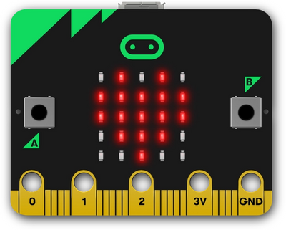
What students will learn
Pupils will construct a program using two command blocks to use the micro:bit’s LEDs to show an image of a heart. In doing this, pupils will increase their confidence in using block-based programming, learn how the emulator can be used to test the accuracy of their programs and learn the steps needed to transfer the program from the computer to the micro:bit.
A good way to rehearse these steps is by challenging the pupils to use the LEDs to show different images linked to those used in the ‘show icon’ blocks.
Can all the pupils program their micro:bits to show an image of a butterfly in under two minutes?
Heart project page
Open in MakeCode

Animated animals
This project will allow pupils to build on their understanding of how to use the micro:bit’s LEDs to display an image by selecting which lights to turn on when creating their own image.
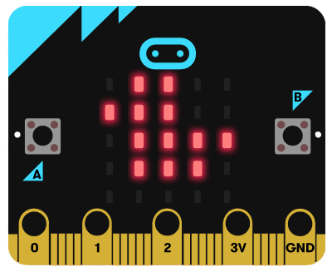
What students will learn
Furthermore, in order to create an animation, they are introduced to repetition in the form of an infinite loop. They will gain an understanding of how repetition can be used to construct programs that are concise are do not repeat commands.
Pupils can explore the effect that changing the value in the delay command block has on the program's output and considered how this knowledge can be applied when creating animations that are trying to achieve an effect: longer delays for soothing and calming animations, shorter delays for animations that are fast-paced and hectic.
Animated animals project page
Open in MakeCode

Next steps projects
For teachers feeling confident teaching with micro:bit, these projects are a great way to teach input/output to students.

Name badge
The name badge project builds on pupils' use of icons to display images and show how the LEDs can be used to represent messages using the ‘show string’ block.
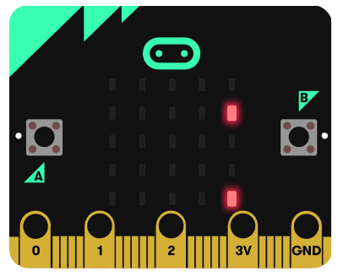
What students will learn
Pupils can consider how they might combine images and text to convey information or meaning and explore the characters that can be used in the ‘show string’ block.
Name badge project page
Open in MakeCode

Shining sunbeams
This project offers pupils the opportunity to apply their understanding of sequence and repetition to create an animation that represents sunshine.
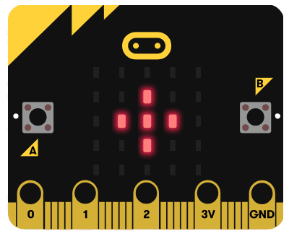
What students will learn
Pupils will plan out the images they are going to use by identifying the LEDs they will switch on to create each image. They will then sequence the images and consider the delay that is needed between each representation, Finally, they will use repetition in the form of an infinite loop to keep the animation running.
This project provides a great starting point for creating multi-image animations. In doing so, pupils are required to consider how their chosen object can best be represented using a set of 5 x 5 LEDs. This provides an excellent opportunity to discuss abstraction: the process of focussing on key information and ignoring the information that is not important in a specific task. They will also need to consider the sequence in which they will place the images and the length of the delays that they will use.
Shining sunbeams project page
Open in MakeCode

Aiming further projects
If you are confident using micro:bit in the classroom, these projects are suitable for teaching input/output to students with some micro:bit experience.

Touch emotion badge
This project can be used to introduce pupils to inputs and how they can be used to activate outputs.
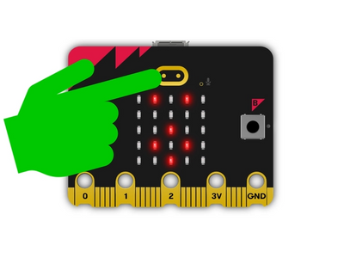
What students will learn
As the micro:bit has several inbuilt input devices, there is no need to attach any extra equipment so time can be sp
ent teaching and learning and not involved with trouble-shooting loose connections. Pupils will learn that input devices are a means of sending data to a computer.
Initially, they will identify the micro:bit’s A and B buttons are examples of these, before being introduced to the touch logo as an additional input device. In constructing a program that allows for different outputs to be triggered depending on the input that is used, pupils can be introduced to the input, process, output model.
They can use this knowledge to consider how everyday devices use the IPO model and identify which inputs are responsible for triggering specific outputs.
Touch emotion badge project page
Open in MakeCode

Frère Jacques loops
Pupils can use this project to develop their understanding of repetition further through the use of count-controlled loops.
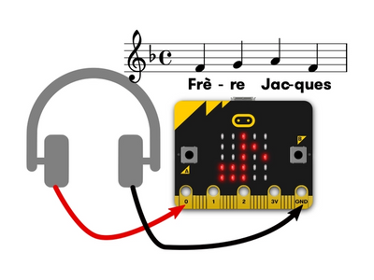
What students will learn
By identifying musical phrases in the well-known song Frère Jacques, they can explore how repetition can be used to repeat a set of instructions an identified number of times. Through listening to the song, pupils can identify patterns in how the phrases are repeated and use this to plan out how repetition, in the form of count-controlled loops, can be used to ensure that their programs are clear and concise.
To take their learning further, pupils can be challenged to complete the song or construct their own program to play another well-known song that repeats simple musical phrases such as Happy Birthday or Twinkle, Twinkle, Little Star.
Frère Jacques loops project page
Open in MakeCode

You may also like
Selection and sensors
Variables

